TinyDB Testing Framework

Eugene Shvets
Version 0.1 May 22, 2003

Overview 1
Architecture 1
Dependencies 2
Sample test case file 2

Overview
The goal of the TinyDB testing framework is to allow automated unit and system testing. The testing framework resides in net.tinyos.tinydb.tests package. Currently, the framework supports:
- Testing the query parser (ParserTester.java) by checking if syntactically correct queries parse successfully, as well as syntactically incorrect ones fail to parse.
- System testing by injecting queries and validating their results (QueryTester.java and supporting classes)

Architecture
This system is built around JUnit unit testing framework, and familiarity with JUnit philosophy is highly recommended for creating new unit tests. The system is organized as follows:
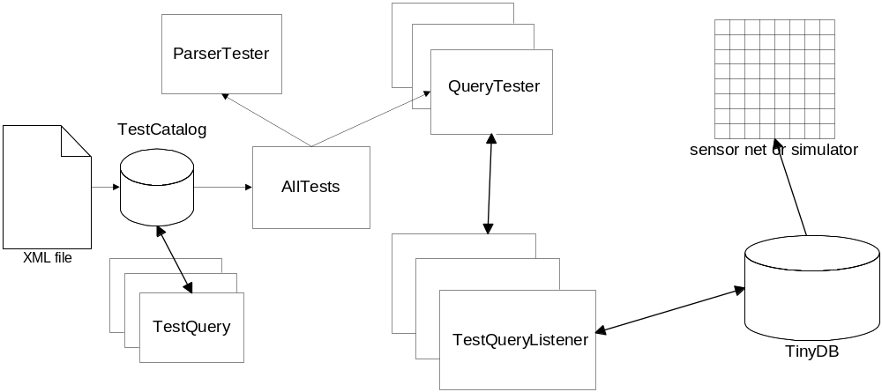
The test cases are declared in an XML file (see Sample test case file below). TestCatalog parses the XML file and creates a TestQuery for each test case. A TestQuery object encapsulates various aspects of a test case, such as the query, expected results, etc. AllTests is the top-level test suite. It creates the catalog by specifying which XML file to parse (currently it is tests.xml). AllTests consists of several test suites: ParserTester for testing the query parser, and QueryTester for end-to-end testing of each parsable query.
QueryTester instantiates a TestQueryListener, which is responsible for injecting the query and accumulating the results. Once the query is injected, QueryTester waits for a test case-specific amount of time. If during this time the listener has not accumulated a number of results equal to or greater than the number of epochs specified in the test case, the test fails. If enough result tuples arrive, they are checked against the expected result tuples from the test case. If all the tuples listed in the test case are present in the in the actual result, the test passes.
Note that the result validation procedure described above is relatively naïve. It can realistically validate only deterministic values such as node IDs. Nevertheless, it provides a useful mechanism for testing TinyDB integrity. Moreover, it can easily be modified to handle range data or wildcards. Alternatively, the simulator could be changed to optionally provide deterministic behavior (for example, by using the same random number seed as during the test case.)

Dependencies
There are two dependencies:
- junit.jar provides JUnit framework.
- xmlParserAPI.jar and xercesImpl.jar provide SAX XML parsing. These are also used for parsing TinyDB catalog file.
All jars are located in tinyos/tools/java/jars.

Sample test case file
<?xml version="1.0" encoding="UTF-8"?>
<!-- List of test cases -->
<tests>

<!-- <test> tag describes an individual test case -->
<test>
<!-- SQL query -->
<query>select nodeid</query>

<!-- list of fields expected in the result -->
<fields>nodeid</fields>

<!-- Should this query be successfully parsed by the parser?
default is false -->
<parsable>true</parsable>

<!-- How many epochs should this query run -->
<epochsToRun>2</epochsToRun>

<!--
Waiting time is the time (in milliseconds) the test suite waits
for this query to complete.
If query does not complete within this time, it is considered to fail.
-->
<waitingTime>10000</waitingTime>

<!--
The <errorThreshold> tag is NOT IMPLEMENTED. The idea is that due to nondeterministic nature of the sensor network, few result tuples may be missing,
or few extraneous tuples may appear. We don't necessarily want
to fail the test case when such abberations occur.
An errorThreshold may be specified to take this into account
-->
<errorThreshold>0</errorThreshold>

<!--
<Results> contains a list of tuples that we expect in the result/
If EMPTY, this query expects no tuples to match it
If NOT PRESENT, this test case REQUESTS that no result checking be done
-->
<results>
<!--
Note that the number of epochs appearing in the list of tuples should correspond to epochsToRun tag above. For this example, number of epochs is 2. We assume that the sensor network (or simulator) is run with 4 motes (including root)
-->
<tuple>1 1</tuple>
<tuple>1 2</tuple>
<tuple>1 3</tuple>
<tuple>2 1</tuple>
<tuple>2 2</tuple>
<tuple>2 3</tuple>
</results>
</test>

<test>
<query>select light</query>
<fields>light</fields>
<parsable>true</parsable>
<epochsToRun>1</epochsToRun>
<waitingTime>5000</waitingTime>

</test>

<test>
<query>select light, temp</query>
<fields>light,temp</fields>
<parsable>true</parsable>
<epochsToRun>1</epochsToRun>
<waitingTime>5000</waitingTime>

</test>

<test>
<query>select light,temp,voltage,nodeid,parent,accel_x,accel_y</query>
<fields>light,temp,voltage,nodeid,parent,accel_x,accel_y</fields>
<parsable>true</parsable>
<epochsToRun>2</epochsToRun>
<waitingTime>50000</waitingTime>

</test>

<test>
<query>select light epoch duration -1</query>
<parsable>false</parsable>
</test>

<test>
<query>select avg(light) group by light</query>
<parsable>false</parsable>
</test>

<test>
<query>select avg(light),temp</query>
<parsable>false</parsable>
</test>

</tests>

